|  |
| --- |
|  |
|  |
|  |
|  |
| Team CPU  **CSC7051 Report** |
|  |
|  |
|  |

Contents

TOC \t "Heading, 1"

1. Peer marking PAGEREF _Toc \h 2
2. Describe and evaluate the development model used (200 words max) PAGEREF _Toc1 \h 4
3. Design (400 words max) PAGEREF _Toc2 \h 4
4. Implementation (500 words max) PAGEREF _Toc3 \h 7
5. Testing (max 200 words) PAGEREF _Toc4 \h 7
6. Evaluation of Project and Product Produced (max 300 words) PAGEREF _Toc5 \h 7

# Peer marking

See Project instructions.

|  |  |  |  |  |
| --- | --- | --- | --- | --- |
| Student number | Student email | Student name | Section(s) Tested | Peer mark (whole numbers only) |
|  |  |  |  |  |
|  |  |  |  |  |
|  |  |  |  |  |
|  |  |  |  |  |
|  |  |  |  |  |
|  |  |  |  |  |
|  |  |  |  |  |
|  |  |  |  |  |

# Describe and evaluate the development model used (200 words max)

Describe the development model used in the development of the product e.g. Agile, Waterfall etc.

The development of this product followed no specific development model. Although there were distinct stages in development. The first stage involved planning and design. The group had several meetings in which we read over the product description and requirements which gave us an understanding of the system we would be creating and how it could work.

The team then began designing a database schema and UML diagram for the system. Then a database was able to be created based upon these designs. After the creation of the UML diagram several basic classes such patient and doctor were coded.

Then the focus shifted to the creation of the user interface system in Java FX. The team designed the several different screens to be used in the system.

The team’s then shifted back to coding the system were the main functionalities were implemented into the system and these were linked to the user interface. During this process the user interface underwent some major redesigns to compliment the new code. In hindsight it would likely have been a wiser decision to wait until the majority of the code was implemented and functioning before designing the user interface. Which probably would have been a better use of the group’s time.

The group then moved onto testing the system and removing and correcting defaults.

# Design (400 words max)

Describe the design of the main aspects of the system

* DB Design (you may include a DB Schema)
* Software System Design (you may include any UML class diagrams, high level system architecture etc.)
* User Interface Design

**Database Schema**

To reduce redundancy and minimise chances of loss of data, we decided to produce a schema to model our database from. Also some of the tables chosen in the schema are designed are for the propose of expanding the system. The reason for this is to create a system that is more flexible and that will be able to cope with future modifications. The entities and relationships in the database schema are as follows:

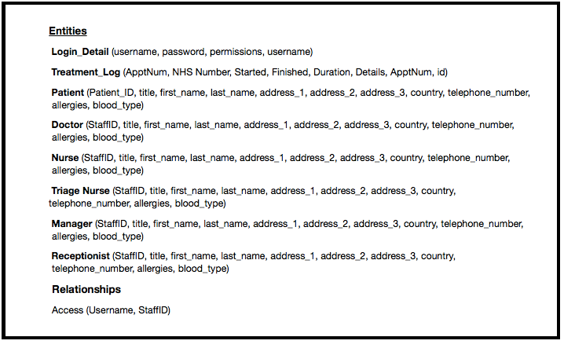 **UML Diagram (Rebecca working on)**

**User Interface Design**

A user interface was created using Java FX and Scenebuilder. The user interface has various pages which we have designed to be consistent in colours and theme. The layout of the pages is quite simple as we intended the system to be intuitive and uncomplicated for users.

The user interface consists of the following pages:

* + - * Login - To be accessed by doctors, nurses and receptionist. A login screen which the user will use to enter the credentials which are their staff number and password.
      * Queue System - To be accessed by the triage nurse. This screen has a drop down box which allows the user to modify the patients position in the queue by assigning them a new triage priority. There is another drop down box which allows the user to select which treatment room to assign to the patient.
      * Reception Layout - To be accessed by the receptionist. The screen allows the user to search for the details of patients who have entered the A&E department. There are four fields where patients details can be entered. These are first name, last name, postcode and NHS number. There is a table of search results of patients in the database whose details match those inputed. The patients information that is displayed is title, first name, last name, street, city, postcode and phone number. The user can select the patient from the list and add them to triage.
      * Treatment Room - To be accessed by doctors and nurses working in the treatment rooms. The first name, last name blood type and known allergies of the current patient being treated are displayed on the screen. The time the treatment began is also shown on the screen. The user has the option to extend the treatment time and there is a text box for the user to enter a summary of the treatment which they can save in the system.
      * Triage - To be accessed by the triage nurse. This screen shows a table including the patients NHS number, first name, surname, allergies and condition. There is a drop down box which is used to assign a triage category to the patient which can then be saved into the system.

# Implementation (500 words max)

Describe your implementation of the main functional parts of the system. You may illustrate this with code  
 snippets and screen shots of the UI.

# Testing (max 200 words)

Describe and evaluate the Testing strategy used throughout the project.

# Evaluation of Project and Product Produced (max 300 words)

Does the product fulfil all the requirements, what additional features does it have… This section should provide a thorough and honest reflection on the process followed in the project and the results of that process.